John Imgrund

4/23/20

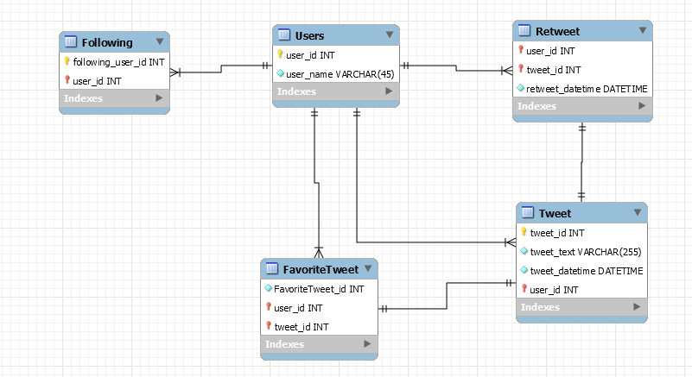

Twitter Clone Data Model Explanation

When going about designing a twitter clone, I decided to start with the quintessential piece: the Tweet. Each tweet contains an id, the text, the datetime it was created, and the id of the user who created it. The tweet_id is auto incrementing so that each tweet is unique and doesn't need to be specifically numbered by the system. For the record keeping of time that will help when displaying user timelines I went with DATETIME over TIMESTAMP. This is because while DATETIME does not automatically account for time zones, it will last longer. TIMESTAMP values are only valid until the year 2038, while DATETIME will last until the year 9999. To account for this the time zone will have to be factored in while inputting data, but it is a small price to pay for thousands of years of unbroken service.

From here the rest of the tables are rather simple. The Users table holds a unique id that auto increments and a username for use in Tweets. The retweet table acts as a list of connections between users and the tweet they have retweeted. It also adds a unique datetime as to when they retweeted it, this is to help with timelines. Favorited tweets is similar, creating a connection between users and timelines, but in this case I created a FavoriteTweet_id to help keep track of how many favorited tweets a user has, and to sort them in an efficient manner as opposed to creating a datetime for each one. I feel a datetime for these is unnecessary since it will not be shown on timelines, but having them in order of when they were favorited would be nice to have, which the id system helps with.

Finally I added a Following table that tracks the other users that a user has selected to follow. This is done by linking your user id to a list of the user_id’s that you follow. This system can also be reverse engineered to track how many people follow a single user, by simply checking the rows in the table where a specific user is being followed.